Smart water fountain

***DESIGN***

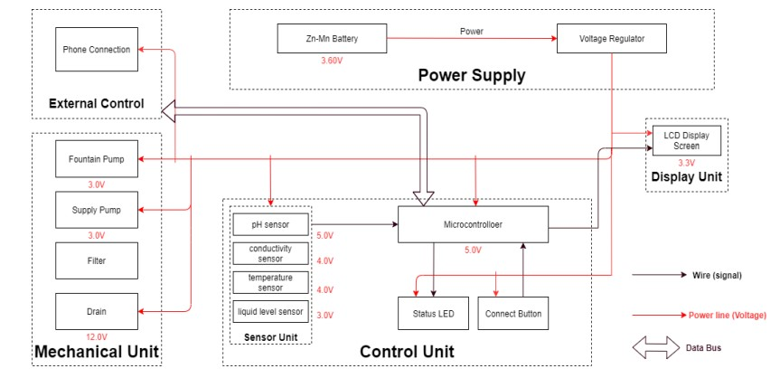

**1.Aesthetic Design:**

* + The overall style and theme of the fountain, which can range from traditional to modern, minimalist to ornate.
  + To view the materials that complement the surrounding environment, such as stone, glass, metal, or acrylic.
  + Incorporate decorative elements like sculptures, figurines, or unique basin designs to enhance the visual appeal.

**2.Size and Location:**

* The size and scale of the fountain based on the available space and the desired visual impact.
* The location of the fountain, whether it's indoors or outdoors, and ensure that it fits seamlessly within the environment.

**3.Water Flow and Effects:**

* + the type of water flow and effects such as cascading waterfalls, laminar jets, or gentle bubbling.
  + Use multiple levels, tiers, or basins to create dynamic water patterns and maximize visual interest.

**4.Lighting Design:**

* + Integrate RGB LED lighting to illuminate the water and surrounding areas.
  + Plan the lighting effects, including color changes, intensity adjustments, and synchronized patterns to create a captivating visual display.

**5.Smart Technology Integration:**

* + - Microcontrollers or IoT devices to control the fountain's functions.
    - Smartphone app or touchscreen interface for user control.
    - Remote monitoring and control options for maintenance and adjustments.

**6.Interactive Features:**

* Interactive elements to engage users, such as touch-sensitive panels, proximity sensors, or responsive water jets that react to movement.

**7.Sound Design:**

* + The audio elements are soothing background music, nature sounds, or the calming sound of flowing water.

**9.Safety Measures:**

* + the safety of users by designing the fountain with protective barriers or covers for moving parts.
  + Incorporate features that prevent water splashing or overspray.

**10.Maintenance and Accessibility:**

* Design the fountain with easy access to components for maintenance and cleaning.
  + Include features like self-cleaning mechanisms or automated water treatment systems to reduce maintenance needs.

**11.Power and Water Supply:**

* + Determine the power source for the fountain's components, which may require electrical outlets or solar panels for sustainability.
  + Ensure a reliable water supply and a proper drainage system.

**12.Weather Resistance (for outdoor fountains):**

* If the fountain is outdoors, select materials that can withstand various weather conditions, including UV rays, rain, and freezing temperatures.

**Connectivity**

**Sensor Integration**

**Design and Prototyping**:

**Deployment and Scalability**

**User Interface and Interaction**

**Data Management**

IoT Sensor Design

TECHNOLOGICAL STACK